[CEN 323 ] Computer Organization & Assembly Language

Lab 1 Journal

Enrollment Number: 01-135232-016

Name : Bilal Aamir

Lab Deliverables (submission guideline)

  - Create a folder named YourRollNumber_Lab1 containing:
- Lab Journal MS Word file (downloaded from the assignments section on LMS)
- .asm files of the practice tasks and the unseen task.
- Add full screen screenshots of the code and output in the Lab Journal.
  - Zip the Folder and upload to LMS.

Task 1

Code:
.data

a db "Name : Bilal Aamir",10,13, "Enrollment : 01-135232-016",10,13, "Section : BSIT-6B",10,13,"$"

.code
main:
mov ax,@data
mov ds,ax
mov dx,offset a

mov ah,9
int 21h

mov ah,4Ch
int 21h
end main
Output:
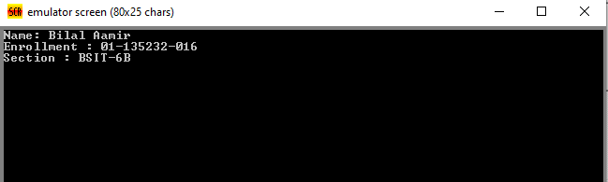

Task 2
Code:
.data

ab db "This",10,13,09,"is",10,13,09,09,"my",10,13,09,09,09,""Name"","$"

.code
main:
mov ax,@data
mov ds,ax
mov dx, offset ab

mov ah,9
int 21h

mov ah,4ch
int 21h
end main

Output:
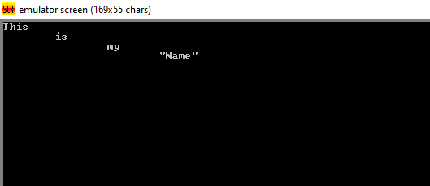

Task 3
Code:
.data

a db "*",10,13,"**",10,13,"***",10,13,"****",10,13,"*****","$"

.code
main:
mov ax,@data
mov ds,ax
mov dx,offset a

mov ah,9
int 21h

mov ah,4ch
int 21h
end main

Outut:
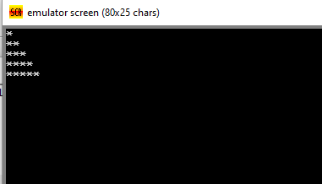

Task 4
Code:
.data

a db 47,92,196,196,92,10,13,179,196,179,196,196,179,10,13,196,196,196,196,196,196, "$"

.code
main:

mov ax,@data
mov ds,ax

mov dx,offset a

mov ah,9
int 21h

mov ah,4ch
int 21h

end main

Output:
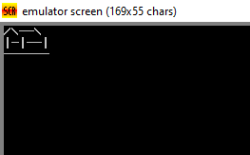

Lab Task

Task 1:
Code (TEXT):

Screenshot (CODE):

Screenshot (OUTPUT):

Task 2:
Code (TEXT):

Screenshot (CODE):

Screenshot (OUTPUT):

Task 3:
Code (TEXT):

Screenshot (CODE):

Screenshot (OUTPUT):

